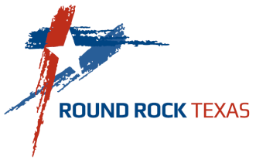
CITY OF ROUND ROCK
(INSERT DEPT NAME)
MEMORANDUM

TO:

FROM:

DATE:

SUBJECT: Performance Improvement Plan (PIP) for Violation of Safety Standards

On date of incident, (describe incident and policy/procedure that was violated).

Based on your continued safety violations, you are being placed on a Performance Improvement Plan (PIP). The PIP will be in effect from (day), (date) through (day), (date).

In your role as a (title), (indicate how you expect them to improve and how it impacts the department)

Over the next (number of days the PIP is in effect) days, you are expected to improve in the complete the following activities that will contribute to your knowledge of creating a safe work environment:

I will meet with you every 30 days to discuss your performance and to provide feedback. Please let me know if there is any additional training you need in order to be successful.

Your failure to provide sustained improvement may result in further disciplinary action up to and including demotion, reassignment or termination.

_____________________________________________ ______________
Supervisor’s Signature Date

_____________________________________________ ______________
Employee’s Signature Date

_____________________________________________ ______________
Witness Signature Date
(Use only if employee refuses to sign)

Cc: Name of Department Director – Name of Department
Sandra Duran, Director - Human Resources & Civil Service

